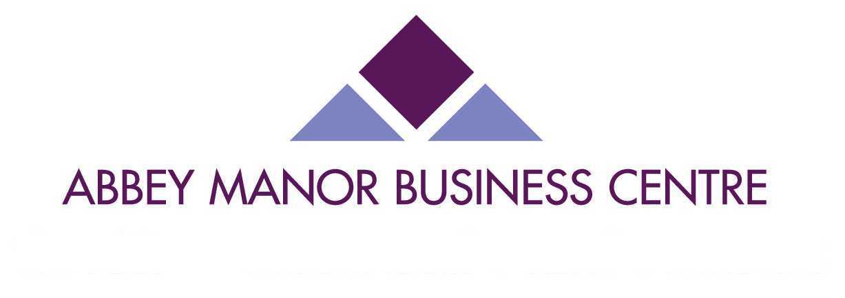
Customer Satisfaction Questionnaire

We would appreciate your feedback by completing the following form. This will help us to make any necessary changes to improve the service and facilities provided by Abbey Manor Business Centre.

Your Name and Company:
Date of Booking
Type of Event
Where did you hear about AMBC?
What made you decide to use AMBC:
Did your delegates have any problems finding the venue?
Would you consider using the venue again?
Would you be happy to recommend the venue to others?

Please rate the venue out of 10 for each of the following: | Booking Procedure
Please rate the venue out of 10 for each of the following: | Location
Please rate the venue out of 10 for each of the following: | Parking
Please rate the venue out of 10 for each of the following: | Size and Layout of Room
Please rate the venue out of 10 for each of the following: | Equipment
Please rate the venue out of 10 for each of the following: | Catering
Please rate the venue out of 10 for each of the following: | Centre Facilities
Please rate the venue out of 10 for each of the following: | Staff

Are there any improvements you would like to see made to the venue, equipment, catering or service that was provided to you and your delegates?
Are there any other comments/suggestions that you would like to put forward?
Are you happy for us to use any of the above information (including your name) in any of our marketing campaigns should we wish to do so?

Thank you for taking the time to complete our questionnaire, we appreciate your assistance and value your opinions.

Jacintha Cooke
Conference Centre Manager
Tel: 01935 848524
Email: JCooke@abbeymanor.com

Abbey Manor Group, Preston Road, Yeovil, Somerset, BA20 2EN

